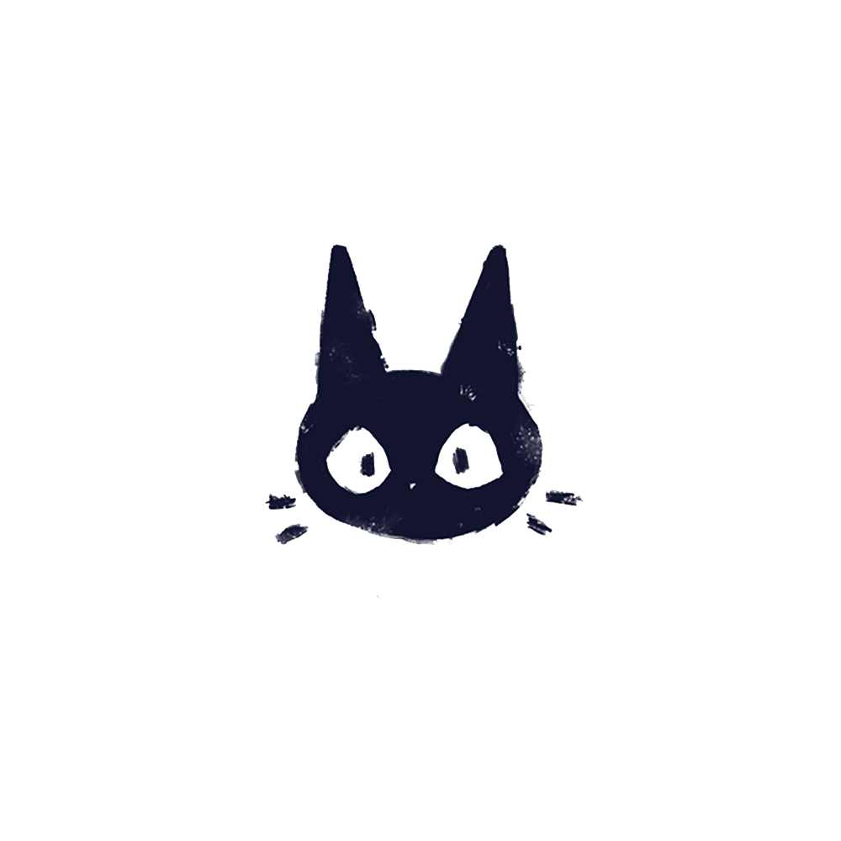  YN  about  A highly motivated Game Artist with a BA (Hons) Animation 1:1 Degree and Master’s in Design and Animation.  Working on a diverse range of daily tasks, I not only design assets for mobile and desktop games but I am also lead designer in my current game.  I work from start to finish on all games and every skill is utilized along the way – for a list of skills and tasks I do, please see below.  Skills  2D Game Asset Design  2D Character Design  Character Concept  UX & UI Design  Game Demo Videos  Texture Packer  Unity  Maya  Figma  Adobe Creative Suite  Git Lab  TV Paint (2D Animation) | Tabitha Lay  Portfolio - tabiimation.weebly.com  Experience  Mid 2D GAME ARTIST • Reflex Gaming • 2022 - PRESENT  Currently working as a mid-weight 2d game artist, my main role is to work on exciting new games for Reflex Games both land and online with an array of themes and styles. I work alongside developers and other artists daily. My tasks can range from the following:  - Research / analyse competitors quality standards.  - Developed cohesive UI style for current and upcoming games as well as individual designs.  - Lead designer on Purrfect Potions, Bugs Money, Jade Princess and upcoming IPs.  - Developed assets alongside developers to understand their needs and requirements.  - Proposed implementation of Spine to improve animation quality.  - Produced game examples through After Effects and Premier to help portray wins for coders.  Mid 2D GAME AND UI ARTIST • AAA • CLIMAX STUDIOS • 2022  2D Game Artist • Derivco/Betway • 2019 – 2021  Motion Graphics Animator and video editor • Deloitte • 2019  Freelance 2D Animator• The Make-a-Wish Foundation •2019  Freelance 2D animator • Skanky pigeon • 2018  Freelance Motion Graphics Animator • text100 • 2017  Character Designer & 2d animator • videowisky• 2017  2D Asset Designer• Scruffybear pictures • 2016  Education  MA Design & Animation • 2019 • Univeristy of lincoln  MA Design and Animation Overall Grade 2018 – 2019 – 2:1  MA Design and Animation Practical Grade – 1:1  BA(hons) Animation • 2018 • University of Lincoln  BA(Hons) Animation Overall Grade - 1:1  BA(Hons) Animation Practical Grade – 1:1  References  Derivco  Dominic Lennon  Dominic.lennon@derivco.co.uk  Make-A-Wish Foundation  Marine Devillers  ceo@makeawishsud.be  Jacobs Massey  Graeme Massey - Deloitte  gm@jacobsmassey.co.uk

